**Project: Feeding Robot**

**Introduction**

We humans have come a long way since the beginning. There have been so many inventions till now but some things remain the same as our ancestors. And one of them is the need to eat no matter who we are.

However, the issue is that many humans are not able to feed themselves because of their physical limitations. Firstly, there are kids who don’t even know how to ask for food. In addition, there are old people who don’t have the strength to feed themselves. Finally, there are people who have lost their arms due to various reasons. Every category mentioned above needs someone to feed them which is a very delicate and troublesome task. Sometimes, the ones feeding may get troubled as this is a boring and difficult task. On the other hand, the ones who are being fed, may not get a good experience if the caretakers are not being caring towards them while feeding or are not really punctual to feed on time.

These problems can be solved by using a feeding robot which will not be as costly as the babysitters or caregivers who are humans. Again, as humans, their actions will not always be the same as the mind of humans changes depending on various factors. Lastly, humans might fail to feed people on time but those robots won’t.

As a result, a feeding robot may be a great solution to make this daily need an affordable and enjoyable task.

**Components**

The components that we need to build this project are-

**Jetson-nano**

Our feeding robot will be detecting food and human faces which is why we need to run object detection algorithms.

And to run these heavy algorithms we need Jetson-nan as the processing device.

**Camera**  
To detect anything, the robot first needs to see that thing.

And this is why we need a camera installed on our robot.

**Manipulator**

The body of the robot will mainly be the robotic arm that is the manipulator.

**End Effector**

As the robot is going to feed there needs to be a finger.

Thus, an end effector is needed.

The camera is going to be set on the end effector.

**Actuator**

An electric actuator will be used as a pneumatic.

Or it won't be accurate and a hydraulic one will create too much noise.

**Stepper Motor**

For feeding, the robotic arm doesn't need to move fast.

But it needs to move to the correct position which is why a stepper motor will be used.

**Charging batteries**

The robot is going to get power through batteries as the robot will work for a certain amount of time while the charge lasts.

**Connectivity**



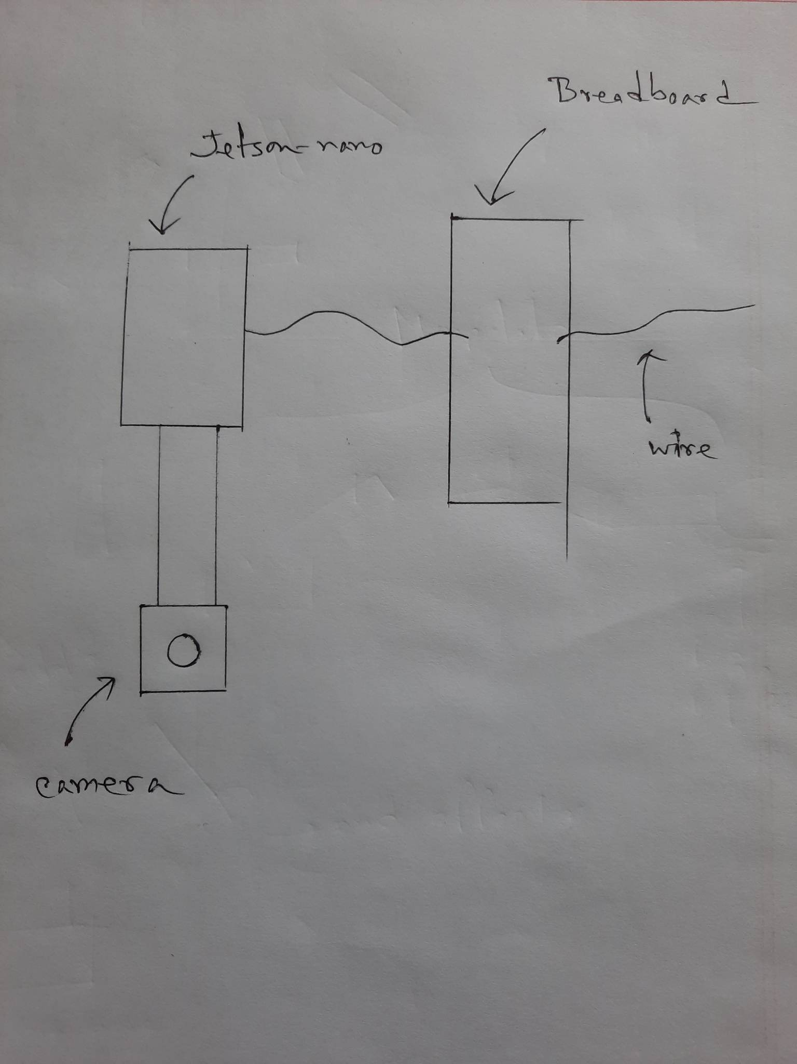

The camera is going to be attached to the Jetson-nano as the captured image or video is going to be processed by the processing device.

On the other hand, wires will be connected to jetson-nano for moving the manipulator according to needs.

**Expected results**

The robot is going to detect what kind of food it is by object recognition and then choose either a knife or a spoon. As there are different types of food- some are solid while some are liquid, the robot will choose different things for picking up the food.

We can set how much food the robot is going to pick for feeding as different people have different choices regarding the amount.

After that, the robot will first detect if the person is a child or an adult. Later, it will detect the mouth of a person and stretch its arm according to the initial distance in between the mouth and the food bowl. Then after getting close to the mouth it will set the correct angle with the mouth and finally feed the human.

By default, the robot is going to keep feeding until there’s no food left in the bowl. Then it will feed water from a bottle in the same method.

However, a person may want to stop eating in the middle of their meal and that’s why the robot will always be trying to recognize the facial expression. If a sad facial expression is detected, it will stop feeding at once. If the facial expression gets back to normal then it will pick a feeder and feed the baby water from it. On the other hand, if an adult shows a stop sign with their hands, the robot will stop feeding them too.

There will be a certain amount of interval in between picking up the food and feeding the food.

**Future Improvements**

It is still a difficult task to make humans drink from a glass as the robot will have to check the amount of water left in the glass and then increase the angle as the water gets less and less. We may be able to solve this problem by keeping track of the amount of water in the glass. However, increasing the angle of the glass with the mouth is still a difficult task.

Humans can’t control the robot with their voices yet. However, we can do so by setting up a mic and a voice recognition system which will let the users control it with their voice.

Sometimes kids want to walk and eat but that’s not possible as of yet. That’s because the robot will then need to detect objects around it too and another arm which will be holding the bowl. A 360-degree camera and a manipulator can be set up to do this task.

**References**

<https://www.nature.com/articles/d41586-022-00072-z>

**Contribution**

**Introduction**

18301268 & 19101145

**Components**

19101444 & 19101147

**Connectivity**

19101444

**Expected Results**

19101147

**Future Improvements**

19101147 & 19101394

**Submitted by**

**18301268** Syed Mahathir Md. Lenin

**19101147** Ahmad Zubair

**19101145** Tasnia Zarin Shailee

**19101394** Mashiya Farjana Jeba

**19101444** Md. Shahriar Khan Limon